Ideation Phase
Define the Problem Statements

Date | 30 October 2025
Team ID | NM2025TMID00168
Project Name | Optimizing User, Group, and Role Management with Access Control and Workflows
Maximum Marks | 2 Marks

Customer Problem Statement Template:
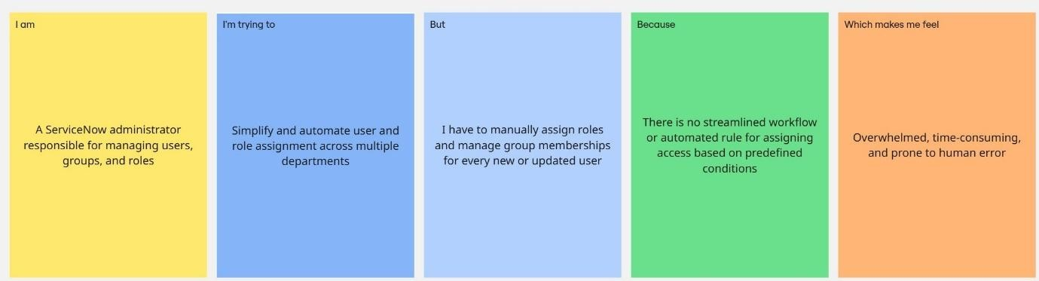
Problem Statement Table:
Problem  Statement (PS) | I am  (Customer) | I’m trying to | But | Because | Which makes me feel
PS-1 | A ServiceNow administrator responsible for managing users, groups, and roles | Simplify and automate user and role assignment across multiple departments | I have to manually assign roles and manage group membersh  ips for  every new or updated user | There is no streamlined workflow or automated  rule for assigning access based on predefined conditions | Overwhelmed, time-consuming, and prone to human error
PS-2 | An IT manager who needs to ensure secure and role-based access within the organization | Implement proper access controls and approval workflows for sensitive data and actions | Access permission s are not consistentl y  managed, and approvals are handled manually. | The absence of an automated access control system increases security risks and delays operations | Concerned about data security and  lack of operational efficiency

